Project Management System

ACME Company has many employees and the company needs an application to assign employees to a project.

Each project can have only one project manager [Note that a Project Manager is also an employee].
Every employee consists of attributes like employee id, name, email, etc.
Every Project consists of project name, client name, one project manager and many other employees who could be SE, testers, etc.

Requirements [Users of this application can perform the following]:
- Add Projects
- Add Employees
- Assign a single project manager to a project.
  - Fetch existing Projects
  - Fetch existing project managers
  - Assign project manager to the project
- Add staff [employee] to an project
  - Fetch existing Projects
  - Fetch existing employees
  - Choose an employee who is not an project manager and assign him to the project
- List all projects and employees working in that project including project manager.
  - Sample output is shown below:

Project: TOMTOM
Project Manager: Sanjeev Gupta
Staff:
- Arun Kumar
- Cathy B
- Danish Aslam
- Karthik J
- Jimmy G

Project: MasterCard
Project Manager: Gopal Krishnan
Staff:
- Bharath R
- Deeraj Gopal
- Divya B

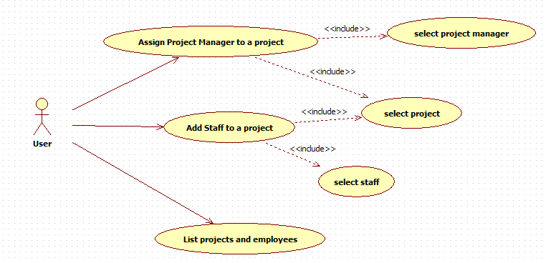

Note:
- The application has to be completed using database
- The application has to be reliable and handle all the exceptions

Capabilities tested:
Define and understand object oriented design principles
Design Java classes which adhere to the object oriented principles
Implement basic Java program for a given basic object oriented design
Define and understand the exception handling in Java to increase reliability of an application
Define and understand the database connectivity using java database connectivity integration libraries

